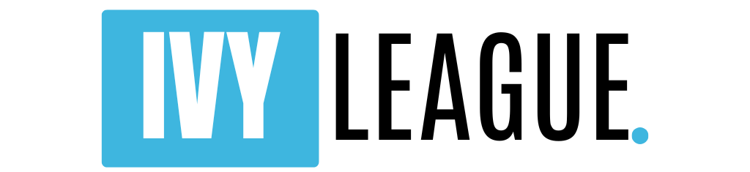

Homepage
Sections:
- Hero Banner (Bold statement + CTA)
- Why Ivy League? (benefits)
- Who We Serve (Targeted audience: CBSE/ICSE/IIT/NIT etc.)
- Our Expertise (Mentors, Ivy alumni, success rate)
- Side-by-Side Comparison Table (Ivy vs India/UK/Canada)
- Application Checklist (for Students & Parents)
- Call to Action (Book a Consultation / Apply Now)
About Us
- Our Story
- Our Team (Mentors, Ivy League alumni)
- Our Mission: “Beyond Admission — Building Legacy”
Why Ivy League?
- Global Recognition
- Career ROI & Legacy
- Academic Flexibility
- Research & Innovation
- Visa & Settlement
- Parent-focused ROI argument
Services
- 1:1 Mentoring
- Profile Building
- Essay & SOP Support
- Application Strategy
- Interview Prep
- Scholarship/Financial Aid Guidance
Success Stories
- Case Studies (India to Ivy: Student journeys)
- Testimonials (Parents + Students)
Resources
- Blog (Ivy admission tips, trends)
- Free Downloads (checklists, planning tools)
- Events & Webinars
Contact / Book a Consultation
- Quick Form
- WhatsApp & Call Integration
- Office Location (if any)
Website Content (Detailed) – Page by Page

🌟 HOMEPAGE
🔺 Hero Banner (First Screen)
"Your Future Starts at the Top."
Get into Harvard. Yale. Princeton. Columbia.
🧠 Guided by Ivy Alumni | 🎯 95% Interview Success Rate
🔘 [Book a Free Consultation] [Explore Services]

💬 Why Ivy League?
- Globally respected by employers, grad schools, investors
- High ROI: $100K+ salaries, top global placements
- Unmatched resources for research, AI, startups, policy
- Flexible, cross-disciplinary degrees (STEM + Humanities)
- 3-Year work permits + strong H1B & PR success
- Elite alumni networks open career doors worldwide

👨‍🎓 Who We Serve
Designed for ambitious students from:
- CBSE / ICSE / IB / Cambridge Boards
- IIT, NIT, BITS, IIIT aspirants or students
- Families with ₹80L+ annual income
- Parents who value global legacy & outcomes

🎯 Our Expertise
- 100% Personalized Mentoring
- Ivy League Alumni & Admissions Experts
- 200+ Offers from Harvard, Columbia, Cornell
- Profile building starts as early as Grade 8

📊 Ivy League vs India/UK/Canada (Table Below)

📋 Student & Parent Checklist
🧾 Must-haves to apply confidently to Ivy League (checklist below)

📞 Call to Action
🎓 Ready for the world’s best education?
🔘 [Book a Free Strategy Call]
🔘 [Download Full Admissions Guide]

Detailed Side-by-Side Comparison Table
Section Title: “Where Should Your Child Study?”
Key Factor | Ivy League (USA) | Top Indian Universities (IITs, DU, IISc) | Top UK (Oxford, LSE) | Top Canadian (Toronto, UBC)
🌍 Global Recognition | ✔ Brand power in 190+ countries | Strong in India, moderate abroad | High in Europe/Asia | Recognized in N. America & Asia
💼 Salary & ROI | $100K+ avg. starting salary in top firms | ₹15L–25L avg. placement packages | £30K–50K salary; limited work rights | C$60K avg. salary; moderate ROI
🎓 Flexibility | ✔ Change majors, explore interdisciplinary fields | Very rigid; locked-in streams | Medium flexibility | Medium-high flexibility
🧠 Research Access | ✔ Nobel-winning faculty, cutting-edge innovation hubs | Limited labs, tight funding | Excellent research reputation | Good access to research funding
🛡️ Safety & Student Life | ✔ 24x7 care, global diversity, vibrant campus life | Limited support, competitive pressure | Good safety, some mental health services | Among safest globally
🛫 Visa & PR Path | ✔ OPT (3 yrs) + H1B + EB PR access | No mobility unless applying abroad | 2 yrs stay back; strict PR path | ✔ Post Grad Work Permit + PR Pathway
🤝 Alumni Network | ✔ Ivy alumni in top policy, VC, tech, and UN bodies | Tech-focused, limited abroad | Academic & public sector focused | Strong in North America
🧳 Post-Degree Outcomes | ✔ Global career/settlement opportunities | Mostly domestic career paths | Limited global roles unless PhD/Law/Med | Balanced opportunities + PR

Application & Admission Checklist
📌 For Students (Grades 9–12 / College applicants)
📌 Task | 📅 Ideal Time
Maintain high GPA (ICSE/CBSE/IB) | Year-round
Prepare for SAT/ACT/TOEFL | Start in Grade 10–11
Build extracurriculars (Olympiads, MUN, volunteering, internships) | Start by Grade 9
Identify leadership/community projects | Grade 9–11
Begin college research | Grade 10
Draft personal statement (essays) | Grade 11
Build recommender relationships (teachers, mentors) | Grade 11
Finalize college list & deadlines | Grade 11–12
Submit CommonApp / Coalition App | Sept–Jan (Grade 12)
Practice for interviews | Jan–Feb (of application year)

📌 For Parents
Task | 📅 Ideal Time
💬 Attend orientation or consultation with mentor | Early as Grade 9
💳 Plan financials (tuition, living costs, 529, investments) | Grade 9–10
🧾 Understand financial aid / scholarship options | Grade 10–11
✈️ Plan travel, visa timelines | After offers (Apr–June)
🔍 Monitor application deadlines | Grade 11–12
🏦 Prepare funding documents for visa/scholarship | Grade 12
📞 Support child with mental/emotional readiness | Always

🎯 Final CTA Section for Website
🎓 Your Child is Exceptional. Let Their Education Match That.
✔ Personalized Ivy Admission Roadmap
✔ Elite Mentors from Ivy Leagues
✔ ROI-Backed Strategy for Global Impact
🔘 [Book a Free Strategy Call]
🔘 [Download the Ivy League Starter Kit]
🔘 [Join Our Webinar – Ivy League Myths & Truths]

